**LAB 12**

**OSPF**

Dynamic Routing has 3 protocols

* RIP
  + NO HOP
  + CHECKS MINIMUM HOPS and then deliver data
  + MAXIMUM HOPS = 15)
* OSPF
  + Open Shortest Path First
  + Prefers Gb Path More Than Mb Path Means Yeh Bandwidth Dekhta Hai
  + Maximum Hops=Unlimited
* EIGRD
  + Maximum Hops = 255
  + Goes Where We Have Minimum Hops And Traffic Bhi Kam Ho

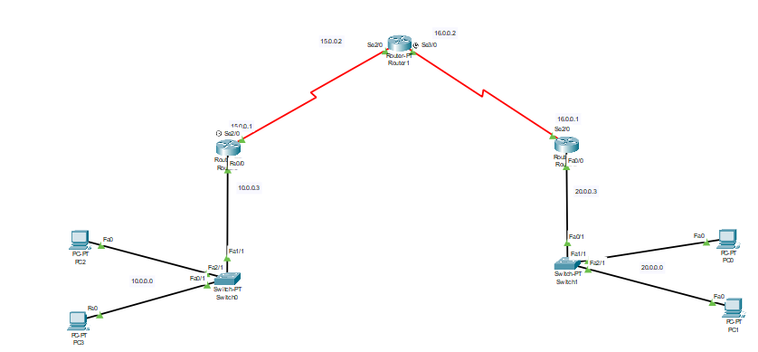

**CONFIGURING ROUTER 1**

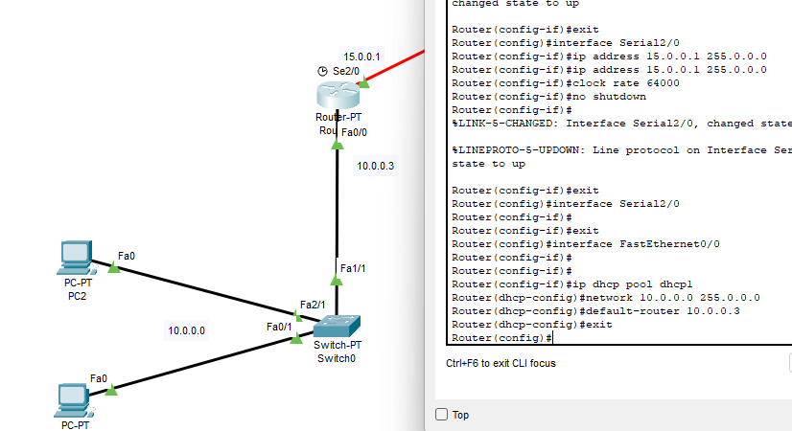

**CONFIGURING ROUTER 2**

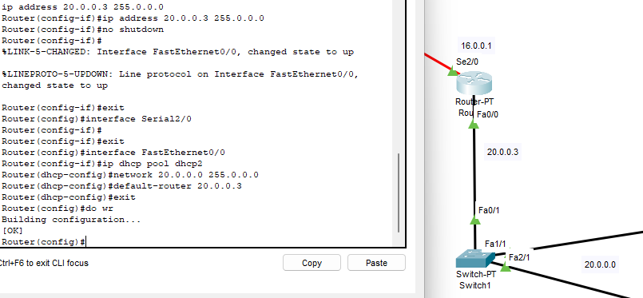

**PCS INFO DISPLAYED AUTOMATICALLY**

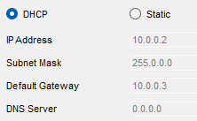

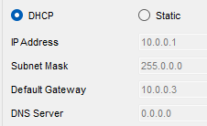

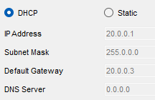

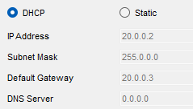

**OSPF ROUTER 1**

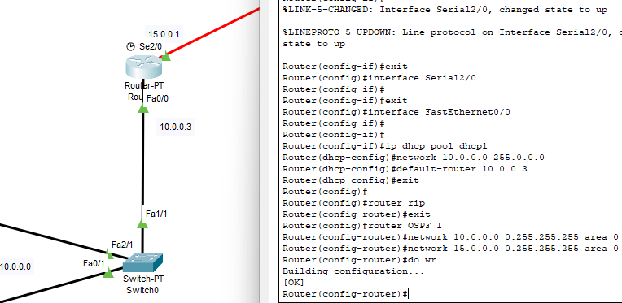

White mask = 255.255.255.255-Subnet mask

**OSPF ROUTER 2**

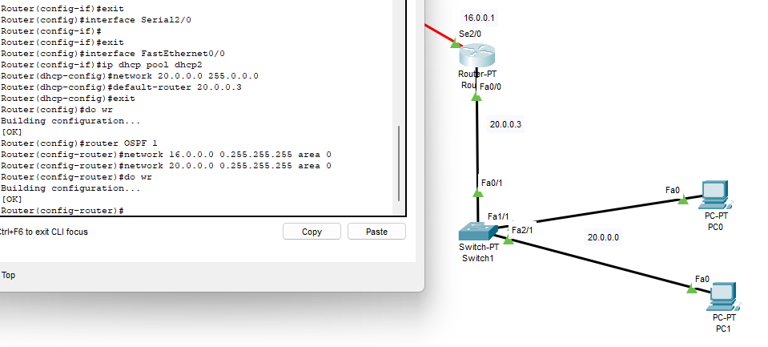

0.255.255.255 = 255.255.255.255-Subnet mask

**Multiple routers ko apsa main commjunicate krne kay liye area 0 se guzarna lazmi hai**

**OSPF ROUTER 3**

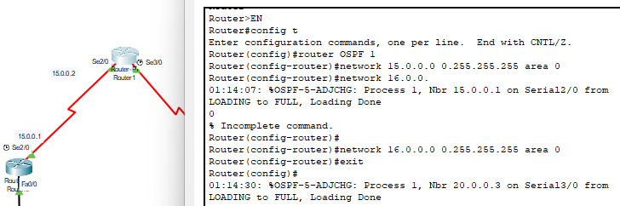

**SHOW IP ROUTE ROUTER 1**

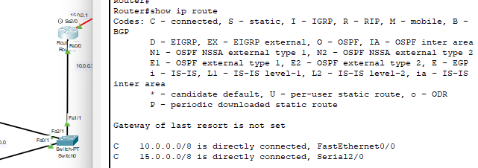

**SHOW IP ROUTE ROUTER 2**

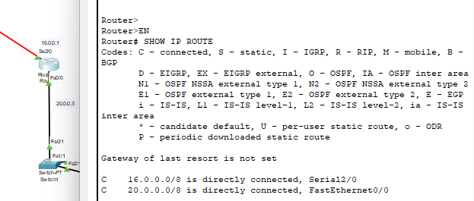

**PING**

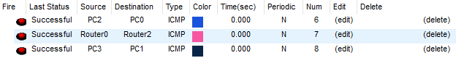

**EIGRP**

